***AI based diabetes prediction system project***

* *Diabetes is a medical disorder that impacts how well our body uses food as fuel. Most food we eat daily is converted to sugar, commonly known as glucose, and then discharged into the bloodstream. Our pancreas releases insulin when the blood sugar levels rise.*
* *Diabetes can cause blood sugar levels to rise if it is not continuously and carefully managed, which raises the chance of severe side effects like heart attack and stroke. We, therefore, choose to forecast using Python machine learning.*

The key analysis objectives of this review are:

* 1.

Publicly accessible and self-created datasets in the area of DM detection.

* 2.

Pre-processing methods that apply to DM datasets.

* 3.

Widely utilized ML feature extraction techniques in the area of DM detection.

* 4.

Widely utilized ML-based techniques for detection, classification, and diagnosis of DM.

* 5.

Widely utilized AI-based techniques for intelligent DM assistant for self-management and personalization of DM therapy.

* 6.

Performance matrices that are used to assess DM detection and [diagnosis algorithms](https://www.sciencedirect.com/topics/computer-science/diagnosis-algorithm).

* 7.

Future research directions for research to be resolved by future scientists working in the area of DM detection and diagnosis.

## How is data contributing to making a decision in Diabetes Detection with AI?

This is the next version of the previous graph. It also shows the same things with some more information about the value of the feature.

* **Feature importance:** Variables ranked in descending order of importance.
* **Impact:** The horizontal location display whether the effect of that value is associated with a higher or lower prediction.
* **Value:** Color display whether that variable is high or low for that observation. Red color devotes the high value and blue for less value. The variation in color of the dot shows the value of the feature.
* **Correlation:** A high level of "Glucose" content has a high impact on having diabetes.

Because of the variety and complexity of DM detection and diagnosis and self-management and [personalization systems](https://www.sciencedirect.com/topics/computer-science/personalization-system), a systematic decision-making framework is used for the selection of papers obtained from the Scopus and PubMed database. The purpose of this framework comprises of, (1) Datasets description, (2) Pre-processing techniques, (3) DM feature selection methods, (4) DM detection using ML approaches, (5) Intelligent DM assistant using AI methods and (6) performance matrices. After thorough exploration procedures, a total of 107 current related significant studies have been listed from the Scopus and PubMed databases. It is anticipated that this review will benefit the research communities in the field of DM detection and diagnosis and self-management and personalization discipline. The key analysis objectives of this review are:

* 1.

Publicly accessible and self-created datasets in the area of DM detection.

* 2.

Pre-processing methods that apply to DM datasets.

* 3.

Widely utilized ML feature extraction techniques in the area of DM detection.

* 4.

Widely utilized ML-based techniques for detection, classification, and diagnosis of DM.

* 5.

Widely utilized AI-based techniques for intelligent DM assistant for self-management and personalization of DM therapy.

* 6.

Performance matrices that are used to assess DM detection and [diagnosis algorithms](https://www.sciencedirect.com/topics/computer-science/diagnosis-algorithm).

* 7.

Future research directions for research to be resolved by future scientists working in the area of DM detection and diagnosis.

*The potential of AI in diabetes treatment and management*

*On the diagnostic setting, screening for diabetic retinopathy successfully uses machine learning to analyse retinal photographs, delivering earlier detection, lower costs, improved diagnostic accuracy and increased access. The technique is currently one of the more widely adopted uses of AI in diabetes care. AI can also play a role in clinical decision-making, such as treatment response prediction 3, which helps quicken treatment optimisation.*

*The ability of AI to rapidly analyse vast datasets of information makes detection at scale a reality. A trial implementation in the UK 4 successfully identifies patients at risk of diabetic foot disease and amputation at a population scale beyond the reach of conventional screening. AI is also being used to analyse massive and complex datasets to identify genetic and other markers, for example, microbiome data, for disease prediction and treatment.*

*The technology also helps put tools In the hands of patients. Novel closed-loop systems – the “artificial pancreas” 5 – combine continual glucose monitoring and automated insulin delivery to offer around-the-clock management. Onboard systems also help patient engagement and compliance with real-time insights into a person’s diabetic status, allowing them to respond accordingly.*

*AI drives many of the scores of publicly available apps for patient self-management, behaviour change and lifestyle tools. For example, photo apps to assess meal content, and lifestyle modification programs using the principles of cognitive behavioural therapy, can help people make better lifestyle decisions.*

*The flow is divided into three stages: input, analysis, and output. Of these, AI is incorporated in the analysis part as one of the analytical tools. In the past AI booms, rule-based algorithms such as an expert system were mainly used in medicine. However, the mainstream of the current AI boom is led by machine learning (ML) and deep learning, and the latter is a type of machine learning that has made significant progress in the last 10 years due to the increase in computational resources accompanied by the dramatic improvement in computer performance. Therefore, one must remember which kind of AI is being referenced, as AI from previous years refers to rule-based AI, whereas AI in the current medical field often refers to machine learning or deep learning. Given these circumstances, the term Medical devices using AI has recently been specified more clearly as AI-/ML-based medical devices.*

*An external file that holds a picture, illustration, etc.*

*Representative flow of using AI in medicine*

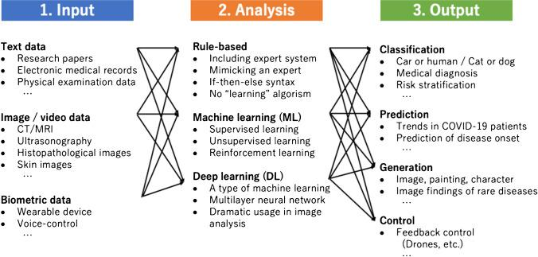

*Thus, the primary approach of using AI in medicine today could be to use machine learning and deep learning as analytical tools to obtain the target output. For example, if the goal is to determine whether a patient has diabetic gangrene based on skin imaging, we would develop a classifier using machine learning that would select images/imaging as the input, deep learning as the analytical tool, and classification purpose and output.*